How to Organize the Directory Structure of a Solution in Visual Studio

Solutions and projects:
Visual Studio has used Solution to organize and manage multiple related Project instead of the original work space since VC 6 was published.
This blog shows a solution example and the expected the directory structure, and then set the properties of projects in Visual Studio step by step to meet our needs.

The Directory Structure of the Solution Example:
This Solution named GMA. A dynamic link library project, ChocolateMilk, and an application project, PureMilk, are included in the solution which needs to a third party library “log4cxx”.
“log4cxx” is a dynamic library in the process of building, so we need the header file, import library (log4cxx.lib, log4cxxd.lib) and dynamic link library (log4cxx.dll).
Suppose that we expect the directory structure as follows:
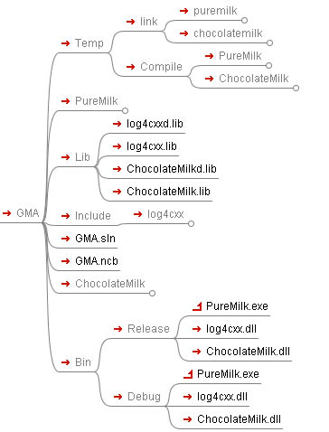
- GMA is the solution directory.
- PureMilk and ChocolateMilk are the projects directories.
- Lib directory is used for storing an import or static library (including third party libraries and their project).
- Include directory is used for storing third party library header file.
- Bin directory is used for storing all of the dynamic link library and executable file, including their own output and third party libraries (both of Release and Debug versions). In addition, the external data file and configuration files that are needed in the running of the program can be put in the directory.
- Temp is used for storing temporary files. “Compile” folder includes the obj files generated by compiler, and “Link” folder keeps the linker output file.
The above directory structure is highly clear. When we make an installation package or package the source code to publish, it can be much easier.
To make an installation package, we just simply package all documents in the “\GMA\Bin\Release\” directory.
When we publish or transfer the source code, we can package all of the files and directories in “\GMA\” except the “Temp” directory (if executable files are not needed, also do not include the “Bin” directory).

What we need?
- Using “\GMA\Temp\Compile\” as the intermediate directory when a project is compiled.
- Using “\GMA\Temp\Link\” as the output directory of every project.
- When the project is an application, copy execution files to “\GMA\Bin\Release\” or “\GMA\Bin\Debug\” after the solution is built. Copy “dll” files to “Bin” and copy “lib” files to “\GMA\Lib\” if the project generates a dynamic link library.
- Run the executable files in “\GMA\Bin\Debug\” or “\GMA\Bin\Release\” and set “\GMA\Bin\Debug\” or “\GMA\Bin\Release\” as the working directory when the solution is debugged.

Set the property of the project ChocolateMilk:
- Using “\GMA\Temp\Compile\” as the intermediate directory when a project is compiled.
- Using “\GMA\Temp\Link\” as the output.
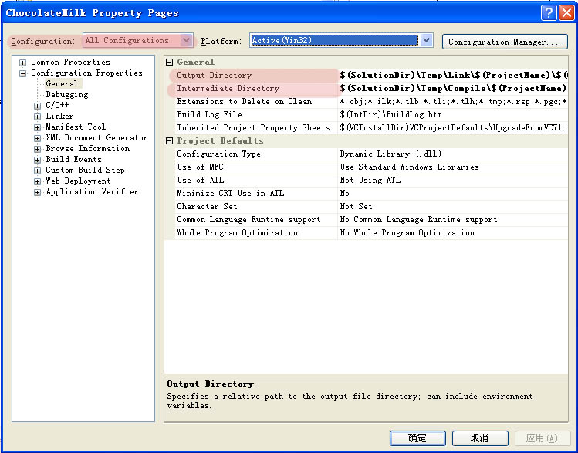
Note the highlighted part, first change the configuration to all configurations, so that we can also modify the Debug and Release configurations at the same time.
Fill following code into Output Directory:
$(SolutionDir) \Temp\Link\$(ProjectName) \$(ConfigurationName)
Fill following code into Intermediate Directory:
$(SolutionDir) \Temp\Compile\$(ProjectName) \$(ConfigurationName)
- Copy “dll” files to “Bin” and copy “lib” files to “\GMA\Lib\” after the project is built:
We usually add a letter “d” at the end of output library files’ name to mark it as a debug version. In the Debug configuration, modify the Import Library:
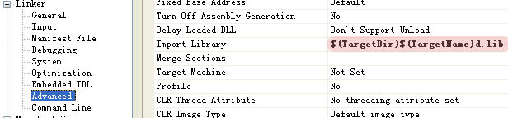
In order to complete this part, write a post-build event:
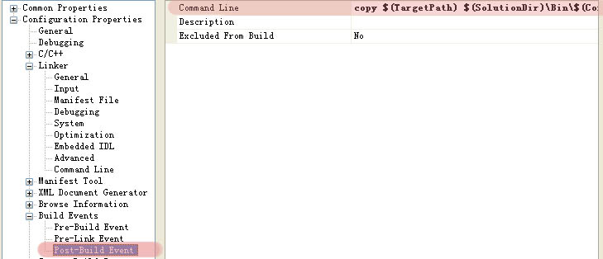
Debug Configuration:
copy /y “$(TargetPath)” “$(SolutionDir)\Bin\$(ConfigurationName)\”;
copy /y “$(TargetDir)$(TargetName)d.lib” “$(SolutionDir)\Lib\”;
Release Configuration：
copy /y “$(TargetPath)” “$(SolutionDir)\Bin\$(ConfigurationName)\”;
copy /y “$(TargetDir)$(TargetName).lib” “$(SolutionDir)\Lib\”;

Set the property of the application project PureMilk:
The first and second step are exactly same with the configuration above.
- Copy execution files to “\GMA\Bin\Release\” or “\GMA\Bin\Debug\” after the project is built.
Fill the following code into post-build event:
copy /y “$(TargetPath)” “$(SolutionDir)\Bin\$(ConfigurationName)\”;
- Run the executable files in “\GMA\Bin\Debug\” or “\GMA\Bin\Release\” and set “\GMA\Bin\Debug\” or “\GMA\Bin\Release\” as the working directory when the solution is debugged.
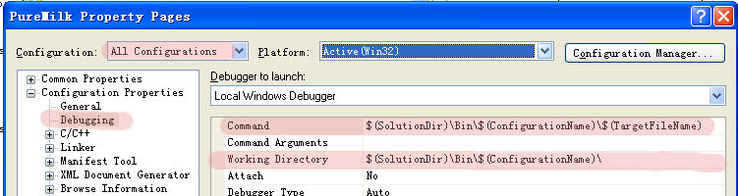
The code filled in command filed:
$(SolutionDir)\Bin\$(ConfigurationName)\$(TargetFileName)
The code filled in Working Directory filed:
$(SolutionDir)\Bin\$(ConfigurationName)\

